
ACP4CLIMATE GRANTS ROUND 1

Annex A.1: Technical Application Form
Application Instructions and Acknowledgement
Please submit your application in English in the following format to ACP4ClimateGrants@tetratech.com on or before 18 November 2026, 5:00 pm ICT.
There is a page limit of 10 single-spaced pages, not including the cover letter, budget or attachments. Please use Arial in 11 pt, no italics. Failure to submit an application in the following format may result in the disqualification of your application.

Cover Page
Date: | Name of applicant: | Address:
Contact person: | Phone: | E-mail:
Name of proposed project: |  | Estimated budget:
Project category: | Proposed Duration of project (in months):

Your application should address the Assessment Criteria specified below and include the following attachments:
  - Budget and notes (Use budget format in Excel).
  - Implementation Plan
  - Staffing Plan;
  - Reference List
  - Applicant Certification.

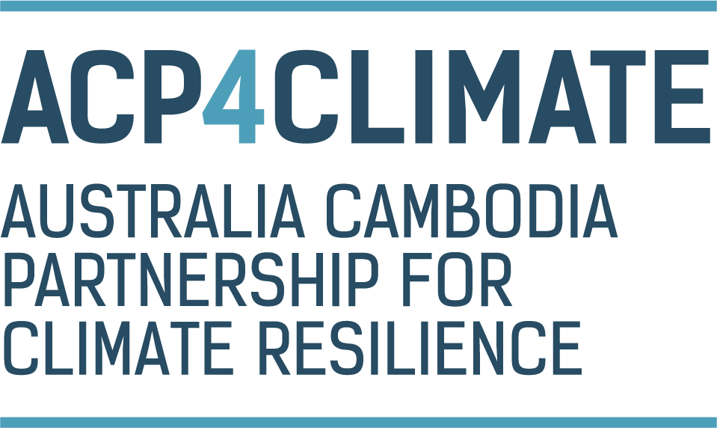

Australia Cambodia Partnership for Climate Resilience (ACP4Climate) is implemented by Tetra Tech International Development on behalf of the Australian Government

Australia Cambodia Partnership for Climate Resilience (ACP4Climate) is implemented by Tetra Tech International Development on behalf of the Australian Government
Assessment Criteria
Your application should address the following criteria:
- Technical Approach and Methodology – 45% (5 pages)

- Strategic alignment with one or more of the Facility outcomes
- Clear, logical, and feasible approach to project delivery
- Realistic implementation plan, sequencing of activities and timeframes
- Demonstrate that project delivery will be locally led, strengthen local resilience and result in long-term outcomes after completion
- MEL arrangements, including approach to measuring results and outcomes, monitoring and reporting arrangements, approach to collecting GEDSI disaggregated data and the generation of lessons learned

- For Demonstration Projects:
  - Explain how the project will test and validate a no regrets initiative on inclusive water governance and IWRM strategies; this should demonstrate how the project will leverage existing activities and/or initiatives to demonstrate and scale up.
  - Identify approaches measuring success and considerations for scaling up good practice activities.

- For Research Projects:
  - Demonstrate how the project will generate actionable evidence on climate-adaptive water governance and identify actionable practices to guide future implementation of water governance initiatives.
  - Provide clear arrangements for monitoring research delivery and quality, track uptake and use of findings and incorporate user and community feedback to improve their usefulness.

- GEDSI – 10% (1 page)
- Demonstrated GEDSI sensitive, responsive, or transformative approach that does no harm.
- Demonstrated understanding of the GEDSI context specific to project activities (i.e. a GEDSI analysis), such as current opportunities and barriers to inclusive decision making relating to water resource management.
- Integration of GEDSI throughout the activity, including consideration of representation in stakeholder engagement, decision making functions, and assessment of how project activities may impact on different GEDSI groups.

- Organisational Capacity, Past Performance and Risk Management – 20% (2 pages)
- Technical, managerial and administrative capacity to deliver the project successfully
- Relevant organisational experience, staff expertise, governance arrangements and partnerships
- Demonstrated performance in implementing grants funded by DFAT or other international donors
- Capacity to comply with DFAT requirements for ethical financial administration and grant management, and DFAT policies and requirements relating to protection from sexual exploitation, abuse and harassment, child protection, modern slavery.

- Budget and Value for Money – 25% (2 pages)
- Appropriate access to expertise, personnel and other resources, including adequate resourcing for MEL and GEDSI
- Effective and practical delivery arrangements
- Demonstrated existing resources and activities that are aligned with the project
- Demonstrated value for money
- Opportunities for co-contributions of additional and/or complementary funding

Attachment B: Implementation Plan
Fill in the below with the results and activities described in your technical proposal. With an ‘X’ indicate the months in which the activities will be carried out. Add more columns and rows as necessary. It is anticipated grants will begin in [List Month/Year the Project anticipates issuing the grant award]
 | Year |  |  |  |  |  |  |  |  |  |  |  | Year
 | M | M | M | M | M | M | M | M | M | M | M | M | M | M | M | M | M | M | M | M | M | M | M | M
Result1:
Activity 1.1
Activity 1.2
Activity 1.3
Result 2:
Activity 2.1
Activity 2.2
Activity 2.3
Activity 2.4
Result 3:
Activity 3.1
Activity 3.2

Attachment C: Staffing Plan
List all project team members (staff and consultants) including their name, position, what role they will play on the project and relevant experience. Highlight key personnel who will manage the project.

First & Last Name | Position | Level of Effort | Status (Hired or need to hire) | Role on Project | Experience

Attachment D: Reference List

Organisation:
Name of Individual:
Role:
Phone:
Email:

Organisation:
Name of Individual:
Role:
Phone:
Email:

Organisation:
Name of Individual:
Role:
Phone:
Email:

Attachment E: Applicant Certification
By submitting this application, the applicant certifies that:
- Authority to apply: The applicant is legally established and eligible to apply under this Call for Applications and Guidelines and has obtained all necessary internal approvals to submit the application.

- Accuracy and completeness: The information provided in this application, including all attachments and supporting documents, is current, complete and accurate to the best of the applicant’s knowledge and belief.

- No misleading information: The applicant has not knowingly provided false, misleading or deceptive information, or omitted information that could reasonably affect the assessment of the application.

- Ongoing duty to notify: The applicant will promptly notify ACP4Climate in writing if any information in the application changes, becomes incomplete or inaccurate, or if any circumstance arises that may affect the applicant’s eligibility, capacity to deliver the proposed activity or suitability to receive grant funding.

- Eligibility and capacity: The applicant satisfies, and will continue to satisfy, all eligibility requirements in this Call for Applications and Guidelines. The applicant has the legal, financial, organisational and technical capacity to undertake the proposed activity and comply with any grant agreement.

- Commitment to deliver the proposed activity: If funding is approved, the applicant intends to undertake the activity substantially as described in this application and will use any grant funds only for the approved purposes and in accordance with the grant agreement, this Call for Applications and Guidelines and applicable ACP4Climate requirements.

- No double funding: The applicant has disclosed all known funding, grants, contributions and other financial support received or sought for the proposed activity. The applicant will not use DFAT funding to duplicate funding received from another source or to claim the same expenditure more than once.

- Conflicts of interest: The applicant has disclosed below any actual, potential, apparent or perceived conflict of interest relating to the preparation, submission or assessment of this application, the proposed activity, the applicant, its personnel, partners, contractors or any other person involved in the activity.

If no conflict has been identified, the applicant certifies that, to the best of its knowledge, there is no actual, potential, apparent or perceived conflict of interest. The applicant will immediately notify ACP4Climate in writing to ACP4ClimateGrants@tetratech.com if a conflict of interest arises or is identified after submission of the application.

Please select one:

☐ The applicant declares that it has no actual, potential, apparent or perceived conflict of interest in relation to this application or the proposed activity.
☐ The applicant declares the following actual, potential, apparent or perceived conflict of interest:

Details: [Insert details, including the person or organisation involved, the nature of the interest, the potential impact and proposed mitigation measures on a separate page.]

- Independence of the application: No current or former ACP4Climate or DFAT official, decision-maker, assessment-panel member or other person involved in the administration or assessment of this grant opportunity has improperly assisted the applicant in preparing or influencing this application.

- Improper influence and inducements: The applicant has not offered, and will not offer, any gift, benefit, payment, inducement or other advantages intended to influence the assessment, decision-making or administration of this grant opportunity.

- Compliance with law and policies: The applicant will comply with all applicable laws, regulations and professional standards relevant to the proposed activity, including requirements relating to fraud and corruption prevention; sanctions and counter-terrorism; work health and safety; child protection; protection from sexual exploitation, abuse and harassment; safeguarding and protection of vulnerable people; gender equality, disability equity and social inclusion; privacy and protection of personal information; and financial management, record-keeping and audit.

- Partners and third parties: The applicant has disclosed all proposed partners, subcontractors, consultants and other material delivery organisations. The applicant will ensure that those entities have the capacity and authority to perform their proposed roles and will manage them in accordance with the grant agreement and applicable ACP4Climate requirements.

- Financial information: The budget and financial information provided are reasonable, sufficiently detailed and based on genuine estimates. The applicant has disclosed any material financial risks, liabilities, insolvency concerns or other circumstances that may affect delivery of the proposed activity.

- Records and verification: The applicant will maintain complete and accurate records relating to the application and, if funding is approved, the activity and expenditure. The applicant acknowledges that ACP4Climate may verify information provided in the application and may request further information, supporting documents, references, or other evidence.

- Assessment and decision-making: The applicant acknowledges that submission of an application does not create an entitlement to funding. The decision to approve or reject an application is a decision of DFAT in consultation with ACP4Climate, made in accordance with this Call for Applications and Guidelines.

- Privacy and information handling: The applicant consents to ACP4Climate collecting, using, storing and disclosing information provided in or in connection with this application for the purposes of assessing and administering the grant opportunity, managing risks, monitoring and evaluating funded activities, and complying with legal obligations. The applicant confirms that it has obtained any necessary consents to provide personal information about its personnel, partners, beneficiaries or other individuals included in the application.

- Public disclosure and transparency: The applicant acknowledges that information about applications, grant recipients, grant amounts, funded activities and outcomes may be disclosed or published where required or authorised by law or Australian Government policy, including through relevant Commonwealth grant reporting systems.

- Consequences of inaccurate information: The applicant acknowledges that providing false, misleading, incomplete or inaccurate information may result in the application being rejected, funding being withheld or withdrawn, a grant agreement being terminated, funds being recovered, or other action being taken in accordance with applicable law and the grant agreement.

Declaration by authorised representative: The person submitting this application is authorised to make this certification on behalf of the applicant and understands that ACP4Climate may rely on the certification in assessing the application and administering any resulting grant.
Applicant declaration: I declare that I have read and understood the Applicant Certification and Declaration above and that the information provided in this application is current, complete and accurate to the best of my knowledge and belief.

Legal name of applicant:

Registration number, if applicable:

Name of authorised representative:

Position/title:

Signature:

Date:

The level of effort (LOE) is the amount of time the staff will be working in the project. If the position is a full time, then the LOE is 100%. The LOE for part-time staff is anything that is less than 100%.

