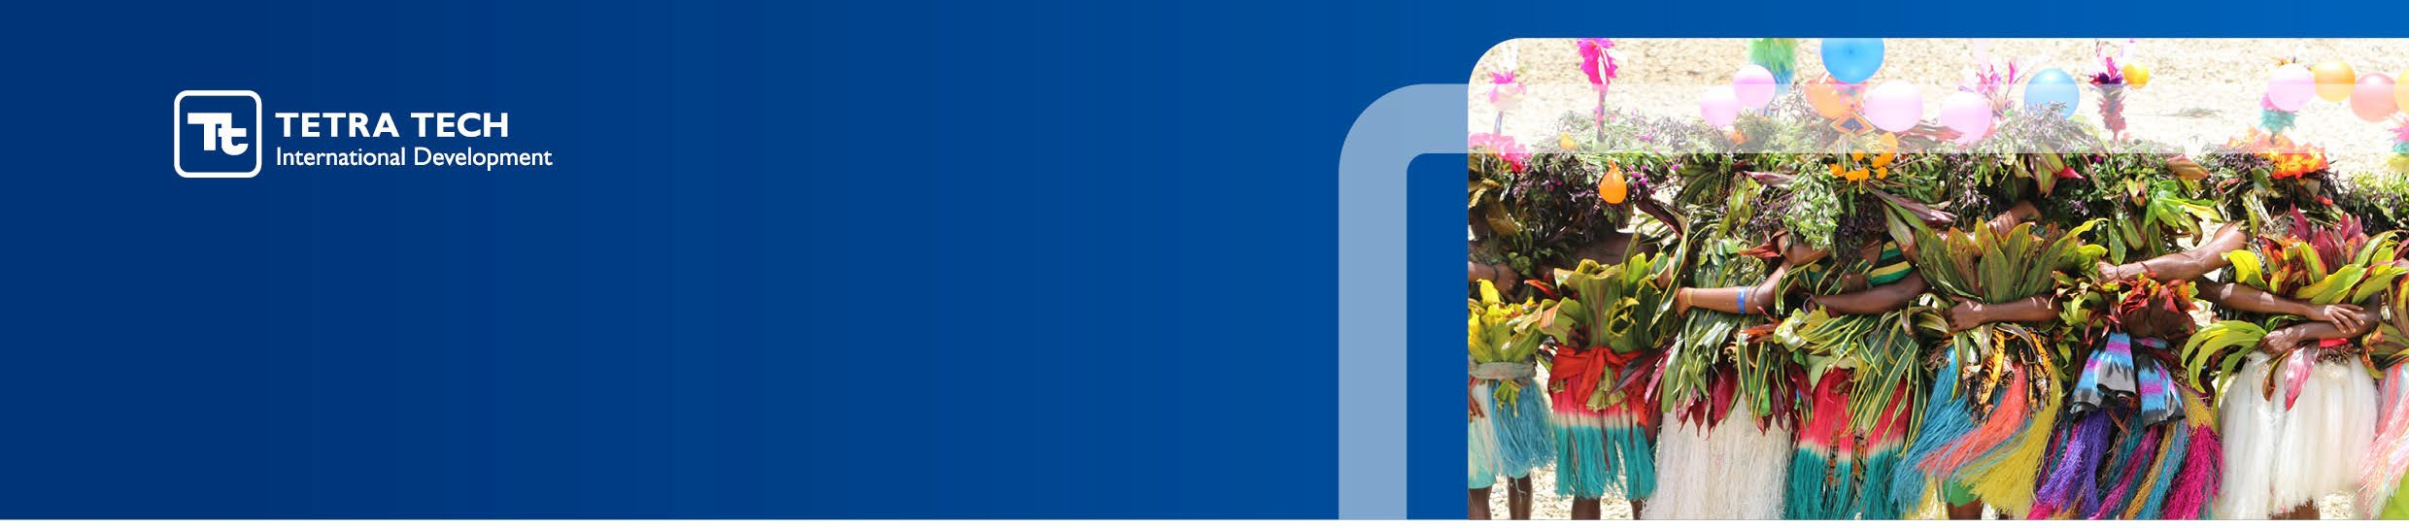

Terms of Reference
Data Collector

Expertise | Local Data Collector (Consultant)
Project | Australia Awards Cambodia
Accountable to | - Research Lead  - Data Collection Lead
Duration of Assignment | 3 months, anticipated to start 16 November 2026 through end of February 2027  Level of Effort (LOE): 13 days
Location | Phnom Penh, Cambodia

Tetra Tech International Development
Tetra Tech has a 40-year history in successfully delivering international development projects on behalf of donors right around the world. Our people work side by side with local partners to support stability, economic growth and good governance, positively changing people’s lives.
Tetra Tech International Development is part of global consulting firm Tetra Tech. The International Development team implements and manages projects designed to strengthen social and economic infrastructure and improve the lives of people in the Asia Pacific region.
Every Tetra Tech relationship is built on trust. Trust that is hard-earned through our proven expertise, our depth of global experience and our commitment to stay one step ahead. We create value throughout the project lifecycle and deliver vital international and local development projects for our clients. Our united group of specialists take enormous pride in collaborating with our project partners. By digging deeper. Thinking smarter. And seeing further. All so we can deliver the smartest solutions, every time.
We welcome applicants of all genders, disabilities, ages, ethnicities, and language group.

Our Values
We are a values-based organisation, and our values reflect who we are and what we stand for, and strengthen our engagement with colleagues, partners and clients through our shared values and behaviours.
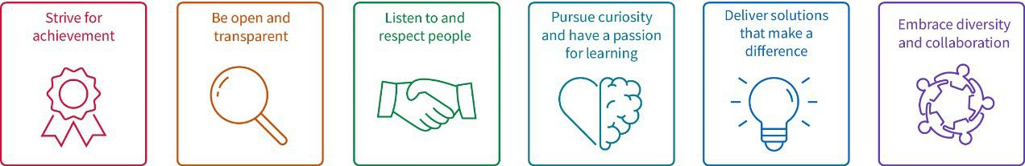

Program Overview

Australia Awards Cambodia (AAC) is a multi-year program (2026 to 2034) managed by Tetra Tech International Development on behalf of the Australian Government, represented by the Department of Foreign Affairs and Trade (DFAT).
AAC’s Goal is to support Cambodia to achieve its development goals through education and knowledge transfer and to build enduring relationships with Australia that advance mutual interests.
AAC targets two End-of-Program Outcomes (EOPOs) and four Intermediate Outcomes (IOs) to realise this Goal:
EOPO 1: Alumni apply their skills, knowledge, and networks to contribute to sustainable development and national development priorities in Cambodia.
EOPO 2: Alumni foster enduring, mutually beneficial relationships between Australia and Cambodia through professional collaboration, institutional partnerships, and shared development goals.
IO 1: Alumni possess the necessary skills and knowledge to contribute effectively to development outcomes aligned with Cambodia’s national strategies and Australia’s development cooperation priorities.
IO 2: Women and gender-diverse scholars have equitable access to, retention in, and completion of Australian scholarships, leading to increased representation in leadership, decision-making, in non-traditional sectors.
IO 3: Alumni view Australia, Australians, and Australian education and expertise positively, reinforcing Australia’s reputation in Cambodia as a trusted partner and preferred education destination.
IO 4: Educational institutions, training providers, and businesses in Australia and Cambodia collaborate through partnerships that support innovation, workforce development, and knowledge exchange.
AAC provides access to prestigious long and short-term study and training opportunities consistent with AAC’s Goal. AAC program core components are:
- Australia Awards Scholarships;
- Australia Awards Short Courses; and
- Australia Awards Enabling Activities (including the Equity Pathways Program, On-Award Enrichment, Alumni Engagement and other targeted initiatives that align with Cambodia’s development priorities).
Strengthening Gender Equality, Disability and Social Inclusion (GEDSI), localisation and climate change considerations, are cross-cutting priorities of the program. AAC aligns all its work to the overarching Goal and the EOPOs, IOs and cross-cutting priorities.
Alumni Targeted Contribution Study Series
Australia has a long-standing partnership with Cambodia in education and human development through Australia Awards Cambodia (AAC). For more than three decades, Australia has invested in Cambodia’s people through Australia Awards Scholarships (AAS). Since 1994, more than 1,200 Cambodians have been supported to study in Australia, creating a substantial and increasingly influential alumni network across government, business, academia and civil society.
A significant analytical focus for AAC’s Phase 3, which commenced in May 2026, will be to complement evidence of individual alumni outcomes with evidence of collective, organisational, sectoral and policy-level contribution alongside broader development and bilateral outcomes. AAC has a strong history of demonstrating how individual alumni apply their skills, knowledge and networks to contribute to development outcomes after returning to Cambodia. Phase 3 will place a greater emphasis on understanding how these contributions accumulate, interact and potentially generate wider change over time. With a substantial alumni network and an established evidence base, AAC is well positioned to look beyond individual success stories and examine patterns of collective and institutional contribution.
There is a strategic opportunity to identify where multiple alumni form meaningful concentrations or clusters within an institution, sector, professional field, province, reform pathway or cross-generational network, and to investigate whether and how their individual or inter-connected contributions have supported broader changes. This offers the potential for a stronger outcomes narrative: a critical mass of Cambodian professionals with Australian education and connections contributing across Cambodia’s institutions, sectors and communities.
As first AAC’s ‘Alumni Targeted Contribution Study Series’, this study will identify and document credible examples of collective alumni contribution. It will apply a contribution-oriented approach ─ noting that establishing attribution, causality or that particular outcome would not otherwise have occurred is beyond the scope of the study. The study Concept Note provides further details.
Summary of Duties
The Local Data Collector will support in-country data collection for the study. The role will participate in interview preparation and fieldwork, support interviews, accurately transcribe interview record and organise qualitative data, assist with coding and data-quality checks, and contribute as assigned to data outputs and deliverables under the study.

The Local Data Collector will:
- Participate in data-collection planning, training and preparation.
- Support respondent identification, scheduling and interview arrangements.
- Conduct or support interviews with alumni and other relevant stakeholders.
- Accurately transcribe, organise and submit interview notes, recordings and related data.
- Ensure interview data is made available to the Local Data Collection Lead and Research Lead for review by the end of each interview day, or no later than the following day.
- Support transcription, data organisation, coding and quality checks.
- Perform data coding using the methods and software identified by the Research Lead.
- Support the consolidation and analysis of quantitative data using Excel, where required.
- Support the analysis and triangulation of interview, quantitative and documentary evidence.
- Contribute to evidence stories or mini-cases, reports and presentations as assigned.
- Report data-quality issues, risks or fieldwork challenges promptly.
- Maintain confidentiality and comply with agreed ethical, data-management and safeguarding requirements.

Milestones:
Consultants in this study will be paid against milestones listed in the table below. The milestones will be reviewed and cleared by the AAC team-task managing the study and DFAT where applicable. Payment proportions will be distributed across the milestones once consultant rates are agreed against the level of effort noted above.

Milestone | Description | Due Date | Means of Verification / Acceptance
Data Collection Training | Complete study orientation, interview training, data-recording procedures and ethical requirements. | Before primary data collection | Participation confirmed by the Research Lead and Local Data Collection Lead.
Interview Data Collection | Complete assigned interviews or interview support activities and submit accurate notes and recordings. | During Stage 2 data collection | Interview records submitted and accepted following quality review by Local Data Collection Lead and Research Lead.
Data transcribing | Complete assigned transcription, and data organisation using the agree templates. | During and immediately after each data collection day
Data Coding and Organisation | Support coding tasks using the agreed code book and software. | At the end of the data collection stage | Coded data reviewed and accepted by the Local Data Collection Lead and Research Lead.
Contributions to Studsy Outputs | Provide assigned inputs to evidence stories, the Stage 2 Final Report and presentation materials. | During Stage 2 and final reporting | Contributions reviewed and incorporated as appropriate.

Due dates will be confirmed in the approved Work Plan.

Selection Criteria
Qualifications
- Master’s degree in research methods, quantitative or qualitative research, communications, social development, monitoring and evaluation or a related field.
- Cambodian national with strong knowledge of the Cambodian context and Australia Awards Cambodia.
- Australia Awards Cambodia alumnus with first-hand experience of the program are encouraged.
- Advanced written and spoken English and strong Khmer-language skills.
Experience
- At least three years of experience participating in qualitative data collection, monitoring and evaluation, applied research or related work.
- Experience conducting or supporting interviews.
- Experience recording, organising and handling qualitative data.
- Experience supporting quality data transcribing, coding and analysis.
- Quantitative data skills using Excel, including consolidation and analysis of data from multiple spreadsheets, are desirable.
- Experience using qualitative data analysis software such as NVivo, Dedoose or an equivalent platform is desirable.

Knowledge and Skills
- Knowledge of Cambodia's institutional, social and development context.
- Knowledge of Australia Awards Cambodia and its alumni network, is preferrable.
- Good interview, note-taking and qualitative data-recording skills.
- Ability to follow interview protocols and accurately capture responses.
- Ability to organise, code and quality-check qualitative data.
- Good understanding of quantitative and qualitative data analysis.
- Good working knowledge of Microsoft Office, particularly Excel and Word.
- Familiarity with Google Workspace and qualitative data analysis software.
- Understanding of informed consent, confidentiality and ethical research practice

Personal Attributes
- Reliable, organised and attentive to detail.
- Respectful and able to build trust with interview participants.
- Clear and professional in communication.
- Able to follow instructions and work effectively as part of a team.
- Punctual and dependable in completing assigned tasks.
- Proactive in raising questions, data-quality concerns or fieldwork challenges.
- Flexible and able to work in person or remotely as required.
- Committed to confidentiality, ethical research and responsible handling of information.

Child Protection
Tetra Tech is committed to protecting the rights of children. We reserve the right to conduct police checks and other screening procedures to ensure a child-safe environment.
Gender Equality, Disability and Social Inclusion
Exemplifying Tetra Tech International Development’s commitment to technical excellence in gender equality, our team of dedicated GEDSI advisers work closely with our partners to ensure a context-specific and consistent approach is applied to all of our programs to improve the livelihoods of the world’s most marginalised groups.
Preventing Sexual Exploitation, Abuse and Harassment, Modern Slavery and Safeguarding Child Proctection
Tetra Tech has a zero-tolerance approach to sexual exploitation, abuse and harassment (‘SEAH’), child abuse and exploitation, modern slavery and safeguarding related retaliation, and this zero-tolerance extends to inaction. Tetra Tech is committed to being a child safe organisation, and to promoting a culture that supports gender equality, and addresses the gendered drivers of violence against women and children. It is committed to fostering a culture where we prevent and respond decisively and appropriately to harm against people, and that all people are treated with dignity and respect, irrespective of country, program, or office where we work. This will require compliance with Tetra Tech’s Safeguarding and other Codes of Conduct and our associated safeguarding policies (Child Protection and Child Safety, Prevention of Sexual Exploitation, Abuse and Harassment (PSEAH) policy and procedure, and Modern Slavery. Any successful applicants will be required to undertake satisfactory referee and criminal record checks prior to being appointed to any position.
Tetra Tech does not charge money or any kind of fee at any stage of the recruitment process (this includes applications, interviews, meetings, processing, administration, service and training). Tetra Tech will never ask for your sensitive information, such as bank account or other login details, including username or password.

Tetra Tech International Development has a 40 year history in successfully delivering international development projects on behalf of donors right around the world, including Australia’s Department of Foreign Affairs and Trade, USAID and the UK’s Department for International Development (now known as the Foreign and Commonwealth Development Office). Our people work side by side with local partners to support stability, economic growth and good governance, positively changing people’s lives.

