Request for Proposal – Regional Trade for Development Program

Event Organisation and Management, On-Site Regional Workshop on Strengthening MSME Capacity for Food Supply Chain Integration in Indonesia
Indonesia | Lao People's Democratic Republic | Myanmar | Singapore | Cambodia | Timor-Leste | Thailand | Malaysia | Viet Nam | Philippines |
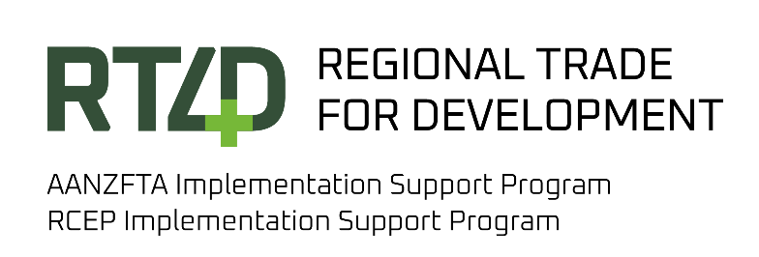

About RT4D
The Regional Trade for Development (RT4D) initiative is funded by both the Governments of Australia and New Zealand. It assists ASEAN Member States (AMS) in meeting their commitments and realising the advantages offered by the Agreement establishing the ASEAN-Australia-New Zealand Free Trade Area, or AANZFTA, and the Regional Comprehensive Economic Partnership, or RCEP.
Through the AANZFTA Implementation Support Program (AISP) and the RCEP Implementation Support Program (RISP), RT4D provides tailored support to enhance the capabilities of ASEAN Member States by strengthening skills, building networks, facilitating policy options and ensuring that trade benefits everyone, including Micro, Small and Medium Enterprises (MSMEs), women and people with disabilities.
The Governments of Australia and New Zealand have committed up to AUD 53.3 million to fund RT4D from 2020-21 to 2027-28.

Project Summary
The RCEP Implementation Support Program (RISP), implemented RT4D Facility, aims to support AMS to realise the full benefits of RCEP through the provision of capacity-building support and access to technical expertise.
The following project is approved under RISP.
- Project Name: Strengthening MSME Capacity for Food Supply Chain Integration in Indonesia
- Project Objectives: The project focuses on strengthening both upstream and downstream segments of the supply chain. At the upstream level, it engages agricultural and food producers and suppliers, while at the downstream level, Nutritional Fulfilment Service Units (SPPG) deliver MBG and Waste Management Organizations convert waste into high-value products. Across these streams, MSMEs benefit from improved access to markers and trade, finance, business formalisation, certification, enterprise development, product processing, and opportunities for partnerships, business matching, or supply chain collaboration. These activities will be tailored to the specific needs of each MSMEs. The project also prioritises women-owned enterprises, persons with disabilities (PWDs), and other marginalised groups, guided by the principles of gender equality, disability, and social inclusion.
The workshop will serve as a platform to present findings and discuss challenges, opportunities and best practices to equip MSMEs across upstream, downstream, and cross-cutting areas with practical knowledge, skills, and exposure to strengthen business performance and readiness for integration into the MBG supply chain.

The Opportunity
The Regional Trade for Development Facility (RT4D) is seeking an event organiser and management (hereafter referred to as the Consultant) to support practical event organisation and logistics arrangements for the delivery of on-site regional workshop.

The event organiser will lead the logistical planning and delivery of a 2-day on-Site regional workshop, and a 1-day business matching event on Strengthening MSME Capacity for Food Supply Chain Integration in Indonesia. The workshop will be held in week 2 or 3 of April 2026 (TBC) in Jatinangor, Sumedang, Indonesia, while the business matching event will be held in May/ June 2026 in Jakarta/Bandung (TBC). Most participants will join in-person. However, the EO will also need to accommodate virtual participation for those unable to join physically.

For a complete Terms of Reference, please refer to the attachment or visit RT4D Website

How to Apply

Interested candidates may apply for more than one consultancy position. Please visit RT4D Website for more information on how to apply.
Apply before 11:59 PM (AEST) Saturday, 7 March 2026.
Please note that only shortlisted candidates will be contacted.

Why Tetra Tech International Development?
As a leading development consulting firm, Tetra Tech International Development works with people and communities to solve some of the world's most complex challenges to achieve a positive impact.
Working with Tetra Tech International Development means working within a values-led organisation that invests in flexible work environments built on trust, safety and well-being. Through unified systems, flexible and supportive workplaces, we provide the foundations required for our team to enjoy the work they do and deliver value every day. Read more about our culture, purpose and values here.
Tetra Tech International Development is an equal-opportunity employer and has a genuine commitment to diversity and inclusion. We encourage people with disability; First Nations Peoples; and people of all cultures, genders, abilities and experiences to apply.

