RFP AM-13055

Part D
Response Forms

Invitation title: Architectural & Engineering Services
Offer submitted by: <Company name>

Instructions to Service Providers for completing this template:
1. You must respond to all sections of this template within the specified fields, in the format requested.
2. Where necessary, any supporting material (e.g. spreadsheets, certificates) should be attached to the back of this template (clearly labelled) and referred to in the relevant field.
3. Complete and sign the Service Provider’s Declaration

You declare that in making Your Offer:
- You understand and accept that Your Offer is subject to the provisions contained in Part A - Procurement Process Guidelines.
- You have declared any conflict of interest that you may have
- You have checked any electronic files contained in Your Offer and that these are free from viruses
- You undertake to keep Your Offer open for the Validity Period specified in the Reference Schedule of Part A - Procurement Process Guidelines.
Dated this day | <insert date> |  | <Insert year>
Signed for and on behalf of <insert name of Service Provider>:
Authorised Person Signature
Authorised Person Name:
Signature of Witness:
Witness Name:

Contents
1 Service Provider Information 1
2 Contact Details 1
3 Financial Viability 2
3.1 Financial History 2
3.2 Default/Other Factors 2
4 Conflict of Interest 3
5 External Resources 3
5.1 Consortia/Partnerships 3
6 Prior Experience and References 4
6.1 Past Experience 4
7 Capacity and Capabilities 5
7.1 Key Personnel 5
7.2 Subcontractors 6
7.3 Organisational Structure 7
8 Work Order Simulation 8
8.1 Task for the bidder 8
8.2 Technical Proposal 8
8.3 Financial Proposal 8
8.3.1 Fees and timeline proposal 8
8.3.2 Hourly and Daily Rates 10
9 Thematic Priorities 11
9.1 Questions 11
9.1.1 Question 1 11
9.1.2 Question 2 12
9.1.3 Question 3 12
9.1.4 Question 4 12
10 Compliance Statements 14
10.1 Compliance with Part C – Draft Contract 14
10.2 Insurances 14
10.3 References 14
10.4 Declaration 15
11 Annexes 16
11.1 Simulated Activity Note 16
Summary 16
Site Description 16
Operational Brief 18
Concept Design – site plan 19
Concept Design – floor plan 21
Reports and Assessments 23

Service Provider Information
Trading Name | <insert name>
Registered Name | <insert name>
Country of Registration and Company Registration Number | <insert Country of registration>  <insert registration number>
Address of registered office | <insert address>
Place of business | <insert address>
Type of entity (e.g. company, trust, partnership, sole trader, other) | <insert entity>
Ultimate Holding Company | <insert entity or N/A if not applicable>
Supplier Entity’s Country of Tax Residency | <Insert your organisation’s country of tax residency. Information to assist you to identify this information is available at https://treasury.gov.au/policy-topics/taxation/country-tax-residency-disclosures>
Key Entity Personnel (e.g. directors, chief executive officer, principal of business etc.) | <insert names and positions>
Telephone | <insert phone number>
Website | <insert URL>
Indigenous Procurement Policy | Is your organisation 50% or more Indigenous owned?  YES / NO (Delete one)  If YES, is your organisation registered on Supply Nation?  YES / NO (see note below) / Not Applicable (Delete one)  If NO, please provide a certificate or letter from a recognised Indigenous organisation.

Contact Details
Contact Person | <insert name>
Position | <insert position>
Address | <insert address>
Postal address  (if different to above) | <insert address>
E-mail | <insert email address>
Telephone | <insert phone number>

Financial Viability
You, the Service Provider are required to demonstrate that you have the financial viability to deliver Tetra Tech International Development’s Requirements. The following questions apply to your business, its parent or any associated entities or any director(s), including any consortium members and partners where relevant.
If the answer to any of the following questions is ‘yes’, provide an explanation.

Financial History
Are there any significant events, matters or circumstances which have arisen within the past 12 months that could significantly affect your operations? Have there been any:
  - Bankruptcy and/or de-registration actions;
  - Insolvency proceedings (including voluntary administration, application to wind up, or other like action) either actual or threatened, against you in the past three years? If so, what (if any) remedial action has been taken?; or
  - Ineligibility listing on the World Bank Listing of Ineligible Firms and Individuals

Default/Other Factors
Are You currently in default of any agreement, contract, order or award that would or would be likely to adversely affect your financial capacity to deliver Tetra Tech International Development’s Requirements? Are there any other factors which could adversely impact on your financial ability to successfully perform the Works?

Conflict of Interest
You must provide details of any actual or perceived interests, relationships or clients which may cause a conflict of interest or potential conflict of interest and actions to prevent or manage the conflicts of interest.

External Resources

Consortia/Partnerships
If You are a member of a consortium or partnership, then You must detail which parts of Tetra Tech International Development’s Requirements that each entity comprising the consortium or partnership will provide and how the entities relate to each other.
Partner 1:
Trading Name | <insert name>
Registered Name | <insert name>
Business Registration Number | <insert number>
Address of registered office | <insert address>
Contact Person | <insert name and title >
Telephone | <insert phone number>
Type of Relationship | <insert relationship>
Period of association | <insert period>
Goods/Services to be provided | <insert goods/service>
Estimated value of Goods/Services | <$>

<insert additional table/s for additional Partners>

Prior Experience and References

Past Experience
Detail four (4) previous or current projects of a similar nature and size to the Works, from the past five (5) years.
Project 1:
Role: | ☐ Prime Contractor |  | ☐ Sub-contractor
Client:
Contract Value:
Commencement:  (MM/YYYY) |  | Completion:  (MM/YYYY)
Name of associated firm(s), if any:
Project Description:
Scope of Services provided:
Client Contact Details
(if able to supply as reference)
Images

<insert additional table/s for additional Projects>
Alternatively, or in addition to above table, attach Project Profiles (with above information clearly identifiable) as an annex to this document.

Capacity and Capabilities

Key Personnel
Detail the relevant experience and expertise of each key staff member and their proposed role in the delivery of the Works.
The bidder shall propose a team with the appropriate professional qualifications and relevant experience to deliver the services outlined in the ToR. The proposed team is expected to include expertise in architecture and engineering disciplines relevant to the assignment, complemented by the necessary support functions to ensure quality, timely, and context-appropriate delivery.
While the specific composition of the team is at the discretion of the bidder, the proposal should clearly demonstrate that the personnel put forward have the technical capacity, regional experience, and professional credentials required to undertake the services outlined in the ToR. Additionally, the bidder shall include in their proposal an overreaching contract focal point to ensure the delivery is aligned across Work Orders.

Name | <insert name>
Position | eg. Engineer | ☐ Local |  | or | ☐ International
Qualifications | <insert qualification>
Professional Association or Registration | <insert registration details>
Professional Experience
Position 1 | Organisation | Start Date |  |  | Finish Date
Duties and Responsibilities | <insert description of duties and responsibilities>
Position 2 | Organisation | Start Date |  |  | Finish Date
Duties and Responsibilities | <insert description of duties and responsibilities>
Position 3 | Organisation | Start Date |  |  | Finish Date
Duties and Responsibilities | <insert description of duties and responsibilities>
Countries of Work Experience | <list countries>
Referees | Name:  Position:  Organisation:  Work Phone:  Email: |  | Name:  Position:  Organisation:  Work Phone:  Email:

<insert additional table/s for additional Key Staff>
Alternatively, attach CVs as an annex to this document.

Subcontractors
Provide details of subcontractors to be engaged in connection with the delivery of the Works.
Subcontractor 1:
Trading Name | <insert name>
Registered Name | <insert name>
Business Registration Number | <insert number>
Address of registered office | <insert address>
Contact Person | <insert name and title >
Telephone | <insert phone number>
Period of association | <insert period>
Goods/Services to be provided | <insert goods/service>
Estimated value of Goods/Services | <$>

<insert additional table/s for additional subcontractors>
Ensure that between 6.1 Key Staff and 6.2 Subcontractors, all required expertise for the Works is captured.

Organisational Structure
Provide details of your organisational structure and the business units relevant to the delivery of the Works (including any necessary diagrams). Indicate clearly positions that will be dedicated to the on-site delivery of the Works versus in a supporting capacity.

Work Order Simulation
As part of this procurement process, bidders are requested to undertake this simulated assignment as part of their proposal submission. The assignment is designed to simulate a typical Work Order (WO) that the awarded firm would be expected to receive for each country/project under the Master Service Agreement (MSA). By completing this simulated assignment, bidders will demonstrate their approach, resourcing, and pricing structure for a typical WO they may be contracted to deliver.
Although this simulated assignment is provided only for evaluation purposes, the following information will constitute a binding commitment should the bidder be awarded the contract and will be utilised in the evaluation of future proposals issued in response of a WO:
- Hourly and daily rates to be applied for the duration of the services.
- Staff resources, including the allocation of personnel to each specific task.
- Indicative time allocation for each task – including in-country site visits, under the assumption that it does not include the ISU review process or other activities outside the bidder’s scope of work.

Task for the bidder
Annex 1 – Simulated Activity Note includes the Activity Plan information for this Work Order Simulation, incorporating drawings, photos and a design brief.
Based on the information provided in the simulated Activity Note, and acknowledging the reports and assessments that are listed in Annex 1, bidders are required to submit a Technical and Financial Proposal ensuring it captures the overall objectives, scope of works and methodologies outlined in the ToR.
The Simulated Activity Note provided as Annex 1 is designed as a simulation of the Activity Plan that would normally be shared with the Service Provider. Reports and assessments carried out by the ISU team during the concept design stage (e.g., land survey, climate hazard assessment, environmental and social safeguarding, etc.) would normally be provided by ISU in an Activity Note alongside an Activity Plan. For practical reasons, these assessments and reports are not included in this simulated Activity Note. Nevertheless, as detailed in Annex 1, the bidder is expected to describe as part of their WO simulation Technical Proposal, how the results and outputs typically outlined in these assessments would be incorporated in their proposal.

Technical Proposal – WO Simulation
In this section, the bidders are required to provide, based on the information in Annex 1 - Simulated Activity Note, a technical proposal that includes a clear description of the methodology and procedures they would follow to carry out the services detailed in the ToR. The bidder should ensure this section showcases the following:
- Overall understanding of the tasks: A demonstration of how the bidder interprets the objectives, scope, and context of the project within the TOR, as well as the Pacific operating environment.
- Design Process and Work Procedures: An explanation of how the design will progress from architectural concepts to detailed design and proposal documentation, ensuring adherence to the applicable national building codes.
- Integration of Thematic Priorities: A clear description, with examples, on how the design package will incorporate Localisation (LC), Gender Equality, Disability and Social Inclusion (GEDSI), and Green Humanitarian Action (GHA) principles.
- Team Roles and Responsibilities: Explain how the proposed staff will be utilised, and how responsibilities will be allocated among the team members.
- Timeline/Sequencing: Provide a narrative of how the tasks will be sequenced, highlighting critical steps and milestones, and including any proposed trips to the site.

Financial Proposal – WO Simulation

Fees and timeline proposal
In this section, based on Annex 1 – Simulated Activity Note, the bidders must provide a price breakdown of their proposed lump-sum fees by project phase, indicating the expected number of working days, in-country trips and staff allocated.
The price proposal should consider all tasks, assessments and reports outlined in the ToR – excluding reimbursable travel expenses - and also consider the following:
- The costs of any additional studies, assessments or site investigations that may be required beyond those listed in Annex 1 as being provided by ISU, (e.g., geotechnical assessments, specialist inputs) and that are outlined in the bidder’s technical proposal.
- Exclude time for ISU review and approval processes, as these are managed externally and should not be included in the bidders’ delivery schedule when estimating days.
Output | Description | Input Days | Fee Subtotal
Architectural Design | To be filled with proposed staff, eg.:
Architectural Design | Architect
Architectural Design | Draftsperson
Architectural Design | Geotechnical Report
In-Country Site Visits: ## trips
Delivery timeline: ## weeks
Subtotal
Detailed Design | Description | Input Days | Fee Subtotal
In-Country Site Visits: ## trips
Delivery timeline: ## weeks
Subtotal
Design Report | Description | Input Days | Fee Subtotal
In-Country Site Visits: ## trips
Delivery timeline: ## weeks
Subtotal
Technical Documentation | Description | Input Days | Fee Subtotal
In-Country Site Visits: ## trips
Delivery timeline: ## weeks
Subtotal
TOTAL

Hourly and Daily Rates
The bidder shall provide details on the personnel allocated for the activities listed in the scope of works, including their names (or positions/roles), and corresponding hourly and daily rates. The information should be presented using the table format provided below, with clear differentiation between staff categories (e.g., Project Manager, Architect, Structural Engineer, etc.). Further information about each person (qualifications, experience, etc.) can be attached separately in the submission package (7.1 Key Personnel).
The rates provided by the bidder will be contractually binding and will also apply when providing services where necessary in the early concept stages, and during procurement and construction phases, including but not limited to:
- Respond to queries and providing guidance to ISU during Concept Design stage.
- Providing clarifications to prospective contractors, assisting the ISU in reviewing technical queries, and participating in pre-bid meetings if required.
- Supporting the bid evaluation process, where necessary.
- Responding to requests, issuing clarifications, and making minor design adjustments during construction phase.

TEAM MEMBER | NAME(S) | HOURLY RATE | DAILY RATE
To be filled, eg.:
Architect
Draftsperson

Thematic Priorities
The ISU seeks to engage a Service Provider with a clear understanding of, and proven experience in, integrating the three core thematic priorities that underpin this program in the Pacific region:
- Localisation and Local Content (LC): Emphasising design solutions, and prioritising processes and methodologies that considers the use of local resources (local contractors, material, labour, operational support) and factors the constraints and limitations present in low resource setting. This also includes knowledge and skills transfer to build local capacity long term.
- Gender Equality, Disability and Social Inclusion (GEDSI): Integrating design considerations that address safe and accessible workspaces and include construction solutions that address specific needs and opportunities for women, people with disability and other marginalised groups, where possible.
- Green Humanitarian Action (GHA): Ensuring the proposed design solutions are resilient to current and projected climate disaster risk, as well as reduces the environmental impact during both the construction and operational phases of the infrastructure.

Questions
As part of this procurement process, bidders are requested to respond to the following questions designed to demonstrate the capacity of the Service Provider to implement the PHWP’s thematic priorities, and to provide evidence of the Service Provider’s previous experience integrating these principles across the Pacific.
Where possible, bidders are encouraged to include additional documentation to support/ provideevidence of successful integration of these themes into their past projects.
The ISU will assess the responses based on the following criteria:
- Relevance and quality of the examples – how well the examples align with the themes and reflect on a successful implementation experience.
- Level of detail - preference will be given to responses providing concrete explanations and evidence, rather than generic examples.
- Contextualised implementation – the bidder provides context specific solutions when implementing the thematic priorities

Question 1
Describe your strategies, capabilities, and available resources to ensure effective engagement with local contractors, suppliers, and technical partners across the Pacific. Please provide specific examples of successful partnerships or collaborations from previous projects in the region.

Question 2
Explain how your designs and/or construction approaches integrate local materials, techniques, and low-resource setting solutions. Please provide specific examples of how these approaches in the Pacific context contribute to project sustainability and local ownership.

Question 3
Outline your approach to transferring knowledge and technical skills to local stakeholders to ensure long-term operation, maintenance, and sustainability of the infrastructure (e.g. training activities, O&M manuals, mentoring).

Question 4
Provide examples of projects or design solutions where you have implemented materials, technologies, or construction methodologies that reduce or mitigate the environmental impact of the infrastructure, and or have a positive or rehabilitative effect on the surrounding site.

Question 5
Explain how your processes and design outcomes address the specific needs of women, persons with disabilities, and other vulnerable or marginalised groups. Include examples of inclusive design features and consultation processes carried out in previous projects in the Pacific region.

Compliance Statements

Compliance with Part C – Draft Contract
Does Your Offer comply with all terms of the proposed Contract? | ☐ Yes  ☐ No
If Your Proposal does not comply with some or all of the terms of the contract You must provide reasons for the partial compliance or non-compliance for each clause below.
Contract Clause No. | Compliance  (N / P) | Explanation/comment

Insurances
Provide details of each insurance policy relevant to Tetra Tech International Development’s Requirement.

References
Please provide up to three references that may be contacted in relation to Your Proposal
Name | Contact Details

Declaration

I/We declare that:
(a) the Conditions of Proposal are agreed;
(b) the Conditions of Contract are agreed; and
(c) the information and particulars provided as part of this Proposal are accurate and correct.

Dated:

Supplier
Signature
*Print name and office held

Witness
Signature
*Print name and office held
*Use BLOCK LETTERS

Annex 1 - Simulated Activity Note

Summary
The PHWP has been engaging with the Ministry of Environment, Climate Change, Disaster Management and Meteorology (MECDM) and the National Disaster Management Office (NDMO) to identify an appropriate location for humanitarian warehousing solutions. In 2025, the PHWP team conducted a site visit to assess the proposed location in X and endorsed it for the construction of the new warehouse.
The site is located within the boundaries of the existing NDMO building, which provides logistical advantages in terms of accessibility and integration with emergency operations. However, it also presents significant challenges due to its steep terrain, exacerbated by the narrow and inclined access road. These circumstances may restrict the movement of heavy vehicles during construction and future operations. In addition, the presence of a stream at the back of the site, combined with the low-lying tier where the PHWP warehouse is planned, requires the incorporation of robust drainage measures and specific design provisions to mitigate inundation risks.
Throughout a series of meetings and discussions with NDMO and other relevant partners, combined with the findings of the land survey and preliminary site assessments, the ISU team was able to develop an operational briefing informing the design of the new warehouse. The briefing highlighted key considerations such as the type of supplies to be stored, the required storage typology (all items will be stored unpallestised), transportation requirements (e.g., 5-Tonne truck for loading and distributions), and the provision of essential auxiliary services such as water tanks, solar power systems and a mobile generator set. Additionally, the ISU was also able to determine an average construction cost of approximately AUD 2,700 AUD/m².
The design for the proposed warehouse lies partially within the footprint of the existing building, approximately 15 meters from the main access gate and 13 meters from the stream at the bottom southern side of the parcel. This location facilitates trucks manoeuvring and offers sufficient space to construct a gentler ramp. Alternatively, a precautious set back from the stream gives additional buffer against inundation threats.
The relatively flat topography of this area, and the potential repurpose of the old building slab intends to reduce earthworks, minimize concrete waste, and lower the volume of soil needed for backfilling. Although earthworks are minimized, retaining walls and adequate drainage systems will be necessary around the warehouse and along the access ramp, complemented by soil stabilisation to reduce erosion.
The proposed warehouse design consists of an 18 x 10 m open-plan space that includes a covered a loading bay of 30 m². It accommodates 33 shelving units distributed along 4 aisles (150–160 cm) for efficient trolley movement. The building provides a flexible 27 m² area supporting stock sorting and packing with a table and a storage cabinet. A 180 cm service corridor along the west side provides access to water tanks and rubbish bins, incorporating a gentle gradient with drainage for stormwater management.
The warehouse has a storage capacity equivalent to 68.5 pallets. This translates, for instance, into sufficient hygiene kits and shelter toolkits for around 360 and 399 households respectively. The final allocation of shelving units will depend on both assessed population needs and the NDMO’s operational capacity to manage distribution. The current layout enables comparable household coverage across most kit types.

Site Description
The site is located just five minutes from the town centre and the main wharf, enabling direct access to maritime shipping connections, crucial for the transportation of supplies. In addition, the location is approximately fifteen minutes by road from the main airport in the island, offering further logistical connectivity by air. Together, these linkages strengthen the site’s potential to serve as humanitarian warehouse across the island.
Despite these advantages, the steep gradient of the access road poses a notable challenge. Heavy vehicles delivering construction materials or later transporting humanitarian supplies may experience difficulties manoeuvring the incline, particularly during periods of heavy rain when road conditions deteriorate.
A land Survey (not provided in this simulation yet assumed to be available in real case Activity Notes) provided accurate information about the topographic conditions of the land, including further details of roof and floor levels of the existing structures.
The land occupies an extension of 3,563 m². It is composed of multiple tiered levels with a significant height difference (9.20 meter) between the highest and the lowest point of the parcel. The portion designated for the PHWP developments - which covers approximately 860 m², lies at the lowest tier of this stepped terrain. While its separation from the existing buildings provides some functional benefits, this position also creates vulnerabilities. Being at the lowest point of the property, the designated area naturally collects surface water runoff from higher grounds. Additionally, the presence of a stream running at the back increases the risk of flooding during heavy rainfall events.
There are several structures occupying the site.
- The NDMO two-storey building siting at the highest point of the parcel.
- The Agricultural Building, a semi abandoned structure located on the lowest tiered area. Currently, one of the walls of this building also serves as retaining wall, supporting both the soil mass and the weight of the NDMO building situated above. PWHP has received written approval to demolish this structure.
- A 20-foot storage container belonging to a local NGO, adapted with a makeshift roof to provide additional covered storage. The container is currently not being used and PHWP has received a formal approval to remove this facility.
- A septic tank servicing NDMO building
- A soak away pit draining septic tank effluent
- An abandoned concrete slab with no particular use and partially overgrown.
- HR radio mast, which according to NDMO, could be moved to suit the construction of the new warehouse.
- Two 5,000L water storage tanks connected to the public water grid.
The site also features two retaining walls. The first, located behind the shipping container, does not appear to be bearing any structural load and may have been constructed in anticipation of further ground works. The second, situated behind the existing water tank, is approximately 1.80 m in height and supports the elevated ground from the upper tier.
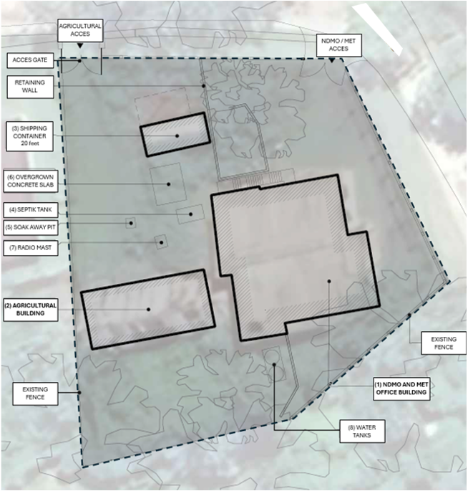
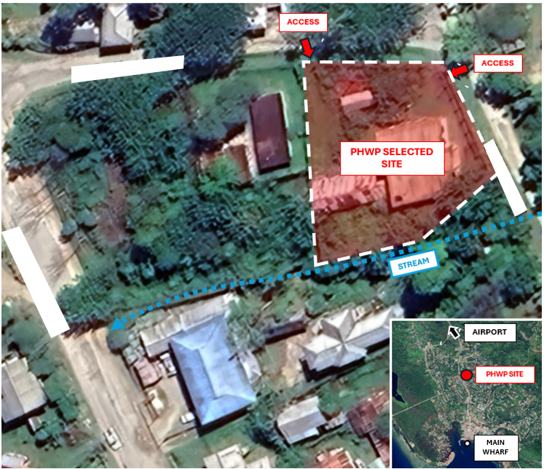

Figure 2 – Existing Site Plan
Figure 1 – Location Plan

Operational Brief
Site Access
Enable a 3-tonne truck (typical overall length 6.0–7.0 m) or flatbed pickup to enter through the existing gate, load/unload safely, and depart through the same gate.
To consider the extension of existing stairway by the NDMO building to enable direct access to the new warehouse.
Ramp Access
Building to be accessible for both people and the flow of manual material handling equipment (e.g., flatbed trolleys) with appropriate gradients (≤ 1:14) and minimal floor threshold levels (≤ 10 mm).
To incorporate appropriate drainage systems that prevent surface and storm water from entering the building, given steep outdoor gradients.
Warehouse Access: Staff / Goods reception / Dispatch / Sorting
Consideration for an open, covered loading bay at the building entry to allow convenient loading and unloading of supplies, with capacity for unpalletising and stock sorting if required.
A wide roller door to provide easy flow of goods and personnel, complemented by one (or two) secondary 1.0 m access door to support staff circulation and connection to the service corridor.
Within the warehouse, by the entry, a flexible open area to enable stock sorting or packing/unpacking activities, with sufficient space for one or two trestle tables.
Storage/ Racking
Provision of a shelving system capable to accommodate the storage of unpalletised goods.
Shelving units and cabinets designed to hold, supplies such as hygiene kits, kitchen sets, shelter toolkits, blankets, etc.
Material Handling Equipment (MHE)
Flat bed and hand trolleys to support the movement of supplies between truck and the warehouse.
Mobile step ladder (1m high) with handrail to facilitate storage and handling of units at higher shelf.
Security
To keep and rehabilitate, wherever needed, the existing perimeter fencing around the land boundary.
Provision of outdoor sensor lights around the area allocated to the new warehouse to provide adequate night-time visibility and safety.
A CCTV system with monitoring capability.
Electricity
Access to the main electrical grid provided through the existing connections available at the NDMO building
Provision of solar system - hybrid, if possible, designed to support the loads of lighting, CCTV, water pumping and roller door between 24 to 48 hours.
Provision of a mobile generator set (5-10kVA) to support critical loads in case of power outages.
Rainwater storage tanks
Provision of rainwater harvesting storage tanks, including a small pumping system, with the capacity to also store water supplied from the network grid.
If considered necessary, a filtration tank to ensure water potability.
Washroom facilities
Provision of bathroom facilities within the new warehouse premises, including at least one unit designed for accessibility by persons with disabilities.
Cleaning / waste disposal
Access to storage units (regular-size cabinets) to accommodate cleaning supplies and office equipment required for the operation and management of stock (e.g., scissors, tapes, wires, etc.).
Allocated area with direct connection to the service corridor for the storage of at least two bins (50L-100L).
Safety fittings
Provision of smoke detector alarms and fire extinguishers, as well as adequate emergency exit signs.

Concept Design – site plan
The proposed location for the new warehouse lies within the footprint of the existing agricultural building. Its position—approximately 15 meters from the main access gate, and 13 meters from the stream - offers an optimal setting due to its flatter topography. This location ensures:
- Adequate space in front of the building for the construction of a three-stages ramp (gradients:10%,15% and 5%) that ensures easier manoeuvring of trucks during the loading and unloading operations. To complement this, the design of the main gate is extended by 3 meters to allow smooth turning movements for vehicles.
- Sufficient buffer from the stream to mitigate risks of inundation during heavy rainfall or flooding events.
- Excessive backfilling to minimize the steeper gradient at the lower area of the parcel.
Access between the existing NDMO building and the new warehouse is provided through the extension of the current stairway at the northern side of the building. This ensures direct access between both facilities, offering notable logistical advantages to the personnel responsible to operate and maintain the warehouse.
Addressing stormwater runoff is a key design consideration. The building is carefully placed offset from the western neighbouring fence (2 to 3 meters), providing an opportunity to construct a generous drainage channel running alongside the building from the gate to the stream.
The design requires removal of the current shipping container and the existing overgrown slab. Additionally, the project includes the demolition of the existing agricultural building (already agreed upon with local partners), potentially maintaining the current slab and repurposing as a sub-base for the new foundation. This approach offers several advantages as it:
- Reduces the amount of ground works at an already levelled terrain.
- Minimizes the environmental impact by reducing the m³ of waste from the concrete slab.
- Offers the possibility to reduce the m³ of soil needed to backfill and raise the floor of the new building.
Although groundworks are minimised in this design, the construction of retaining walls will be necessary. These will provide support between the former agricultural building platform and the NDMO building. Additional retaining structures and vegetative stabilization will also be required along the access ramp to enhance soil stability and reduce the risk of localised landslides from the higher tiered ground. The design specifications and exact location of these walls will be determined in later design stages of the project, based on the results of the geotechnical studies and engineering assessments of the existing walls.
The design includes a washroom block adjacent to the main building, comprising two toilets, one of which is designed to be accessible for persons with disabilities.

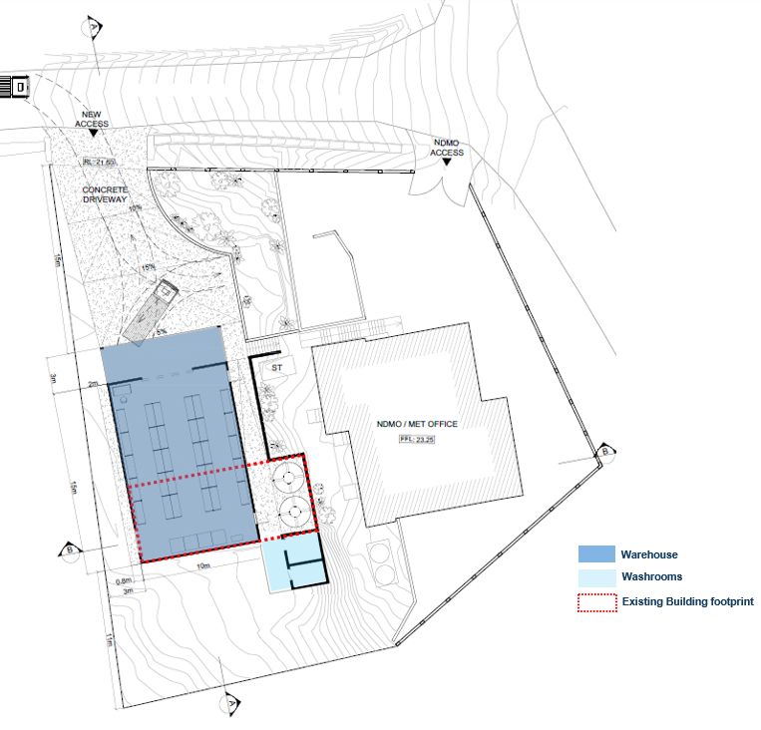
Figure 3 – Proposed Site Plan

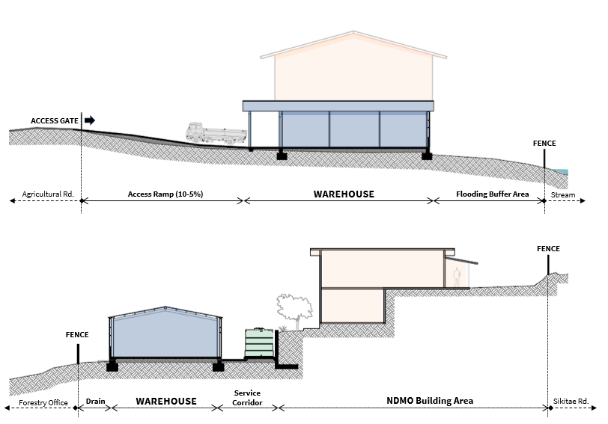

Figure 4 - Section A

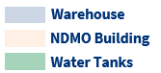

Figure 5 - Section B

Concept Design – floor plan
The proposed warehouse design features an open-plan space with approximate dimensions of 18.00 x 10.00 meters that includes a covered loading bay of 30 m². To support the operational requirements of stock sorting and packing/unpacking activities, the entrance of the warehouse is designed as one flexible open area of approximately 27m². This space is planned to accommodate one or two trestle tables along with storage cabinets for essential equipment, such as cleaning products and warehousing equipment.
Outside, a 180 cm wide service corridor along the western side of the warehouse provides access to the water tanks and the washrooms located at the back. With a gentle gradient, the corridor is also designed to accommodate a drainage system that collects stormwater runoff from the access ramps and the higher tiered grounds.
The building includes three main openings. At the front, a wide roller door connects directly the loading bay and the sorting area, ensuring efficient movement of goods and personnel. In addition, two 100 cm doors are provided to meet safety requirements and to facilitate access to both the service corridor and the NDMO building stairway.
The storage capacity of the warehouse has been calculated using standardised pallet dimensions and kit unit specifications. The amount of shelving units and racking allocated for each item will be determined by future conversations on the Supplies component. The indicative stock listing is included as a guide to the potential capacity of the warehouse, targeting a similar number of households per kit type.
This layout (see Figure 6) provides two typologies of shelving units: 30 units measuring 76 D x 180 W x 220H, and 3 larger units of 90 D x 180 W x 220H. The narrower shelves are arranged in four rows, with three corridors—ranging between 150 cm and 160 cm wide—running between them to ensure efficient movement using flatbed trolleys and mobile step ladder. These corridors connect the front access of the building to the rear, optimizing internal circulation. At the back of the warehouse, the 3 larger shelving units enabling the stacking of larger items such shelter toolkits.
The storage capacity accommodates the equivalent of 68.5 pallets, which corresponds to a minimum of 360 supported households / 1,800 persons.

 | Designation | Area (m²) | % NFA | Storage/ Support
 | Storage -1 (shelving units: 76 x 180 x 220 cm.) | 44.00 | 31 % | 40% storage
 | Storage -2 (shelving units: 90 x 180 x 220 cm.) | 6.00 | 4 % | 40% storage
 | General Storage (MHE, cleaning, etc.) | 7.00 | 5 % | 40% storage
 | Sorting area | 27.00 | 19 % | 60% support
 | Circulation | 56.00 | 41% | 60% support
 | Net Floor Area (NFA) | 140.00 | 100%
 | Services | 27.00
 | Loading bay | 30.00
Table 1 - Schedule of Areas

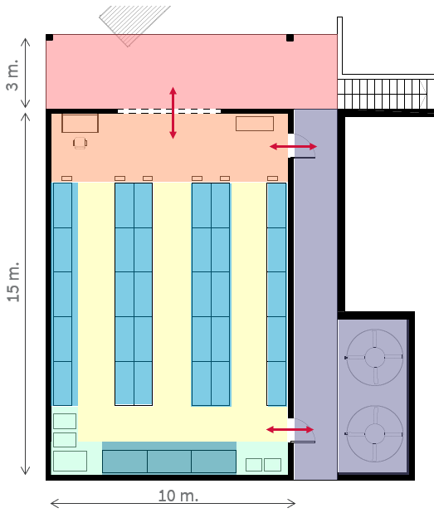

Figure 6 – Layout

Reports and Assessments
* For practical reasons, the outcomes of the following Assessments and Reports are not included in this Simulated Activity Note. Nevertheless, the bidder is expected to describe in their WO Simulation technical proposal how the types of results and outputs outlined in these specific assessments would be incorporated in their proposal and inform their design proposal.
- Climate and Disaster Risk Assessment: Desktop level report that identifies, evaluates, and categorizes potential natural hazards (temperature, rainfall, wind, earthquake, tsunami, and sea level rise) in that location and that may impact the design, construction, and maintenance of the warehouse throughout its design life. Where necessary, the report may also include site specific assessments (i.e., inundation risk) to address hazards that can’t be evaluated at desktop level.
- Environmental and Social Safeguarding Assessment: Report prepared in accordance with DFAT’s Environmental and Social Safeguard Policy, identifying potential impacts on the population and environment associated with the construction of the warehouse, and proposing mitigation measures and considerations to minimize any negative effects.
- Local Construction Market Assessment: Desktop-level report identifying high-level information on local capabilities (e.g., contractors, available materials, etc.), the construction regulatory framework (e.g., national building codes, building permits processes, etc.), and key constraints and opportunities within the country’s construction sector. This report also identifies an estimated construction cost (approximately AUD 2,700 AUD/m²) to help guide the procurement process.
- Procurement Plan: Report outlining the proposed strategy for procuring construction services from local or international suppliers, based on existing in-country capacities and available resources.

